**Assignment week 4**

5 Things I would improve in the Domino App:

1. The “start new Order | Bestellung Neustarten” is in a very bad position:

The size, font and color are same as the other texts. It is way down nobody looks at it. Also the back buttons color is in my opinion bad. There is so much space not used.

Improvement: Bestellung Neustarten or the home button should be the logo, a progress bar should be there, so you can go back everytime, you don’t know where you are

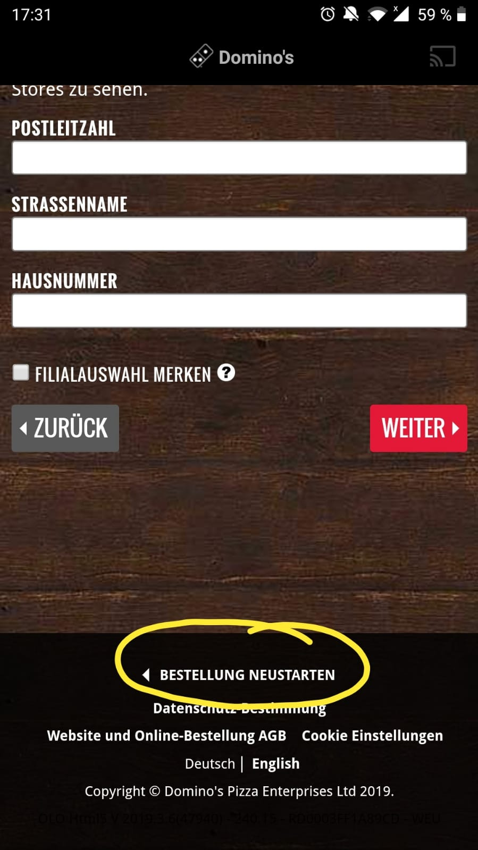

1. You don’t know what now and later means in the context. When you click between these 2 buttons, nothing changes. You also have to give a time when you want to get it now.

Improvement: Explain what the buttons do, change a little bit the design so people don’t get confused.

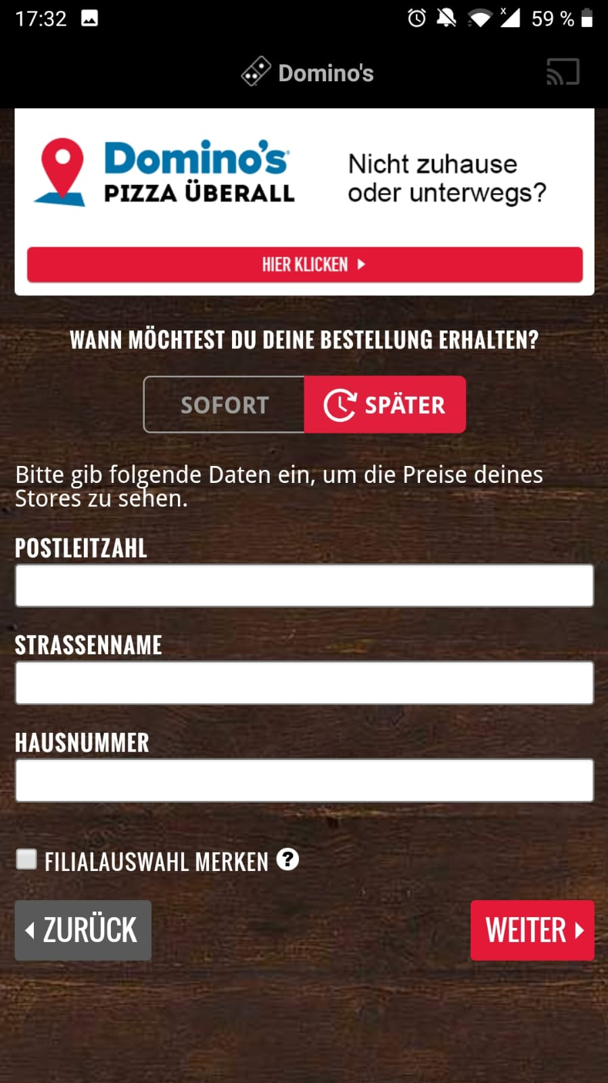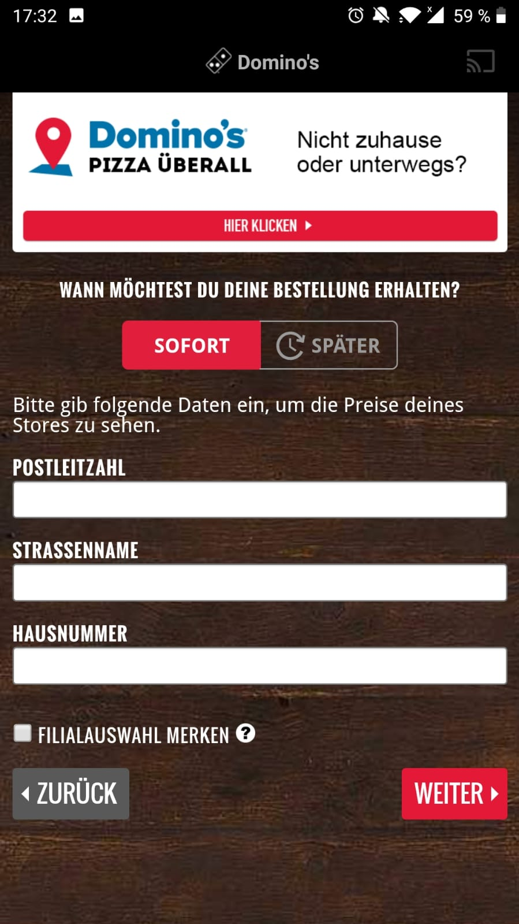

1. There is no more option when you choose a pizza, I wouldn’t know that you could add toppings to it. You have to click on the picture.

Imrpovement: Only show the option to click on the picture, no 2 menus and toppings as a dropbar menu.

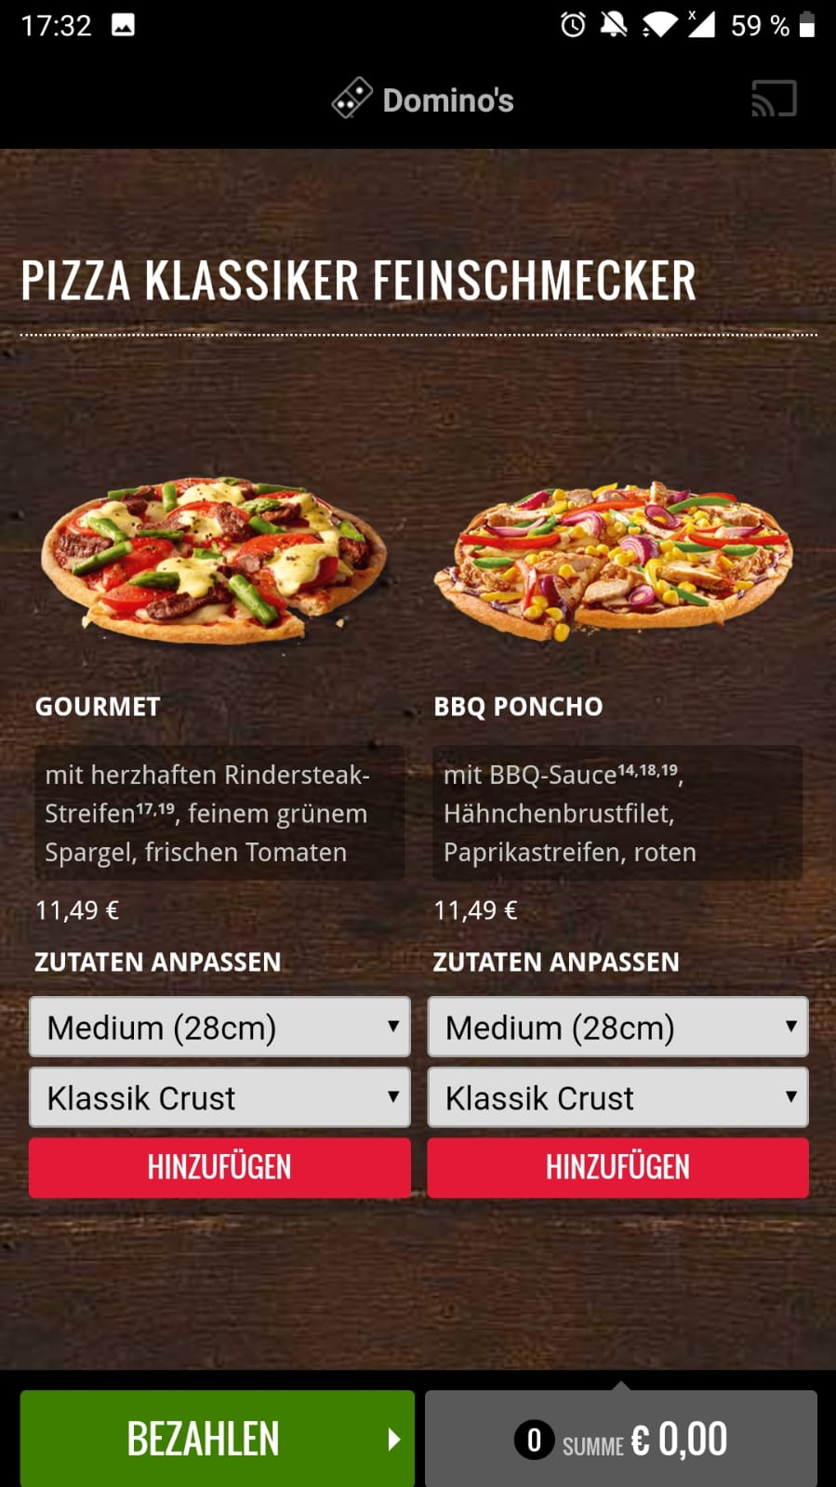

1. When you click on the first option for the crust menu and choose cheesy crust and afterwards on the picture. It isn’t saved.

Improvement: don’t have to menu option to choose a pizza

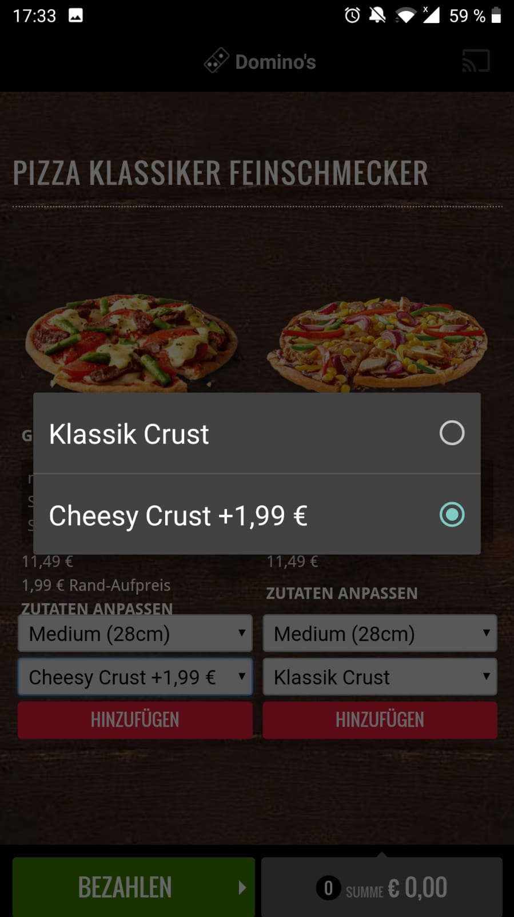

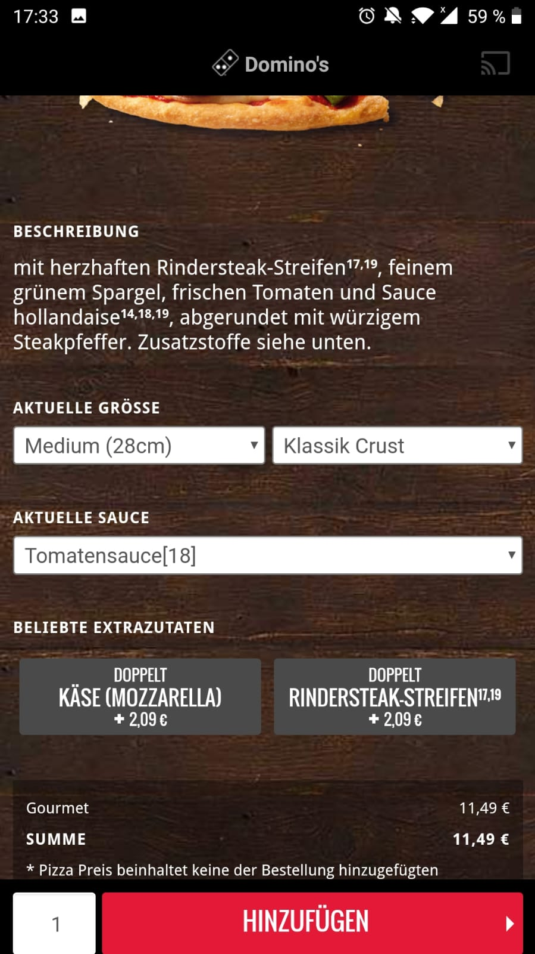

1. The toppings are ordered alphabetically which is not a good design because, you have to search for the topic you want. Not customer friendly

Improvement: Specify categories in which the toppings are safed, easier for the customer

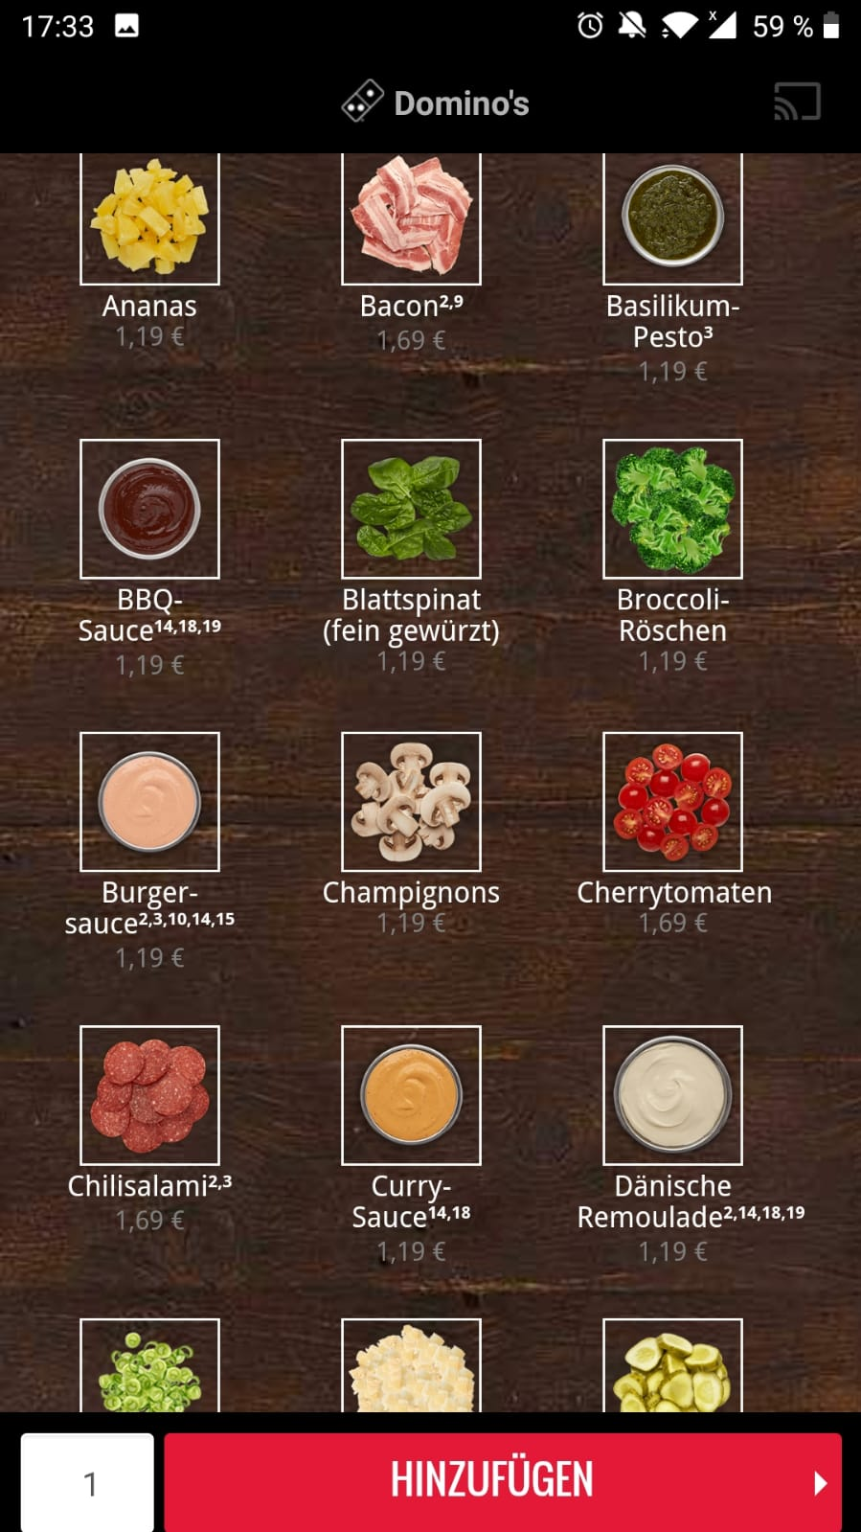

1. The overall feeling of the app is not good. I got confused very easily.

Improvement: have me as a developer.

Good things of the App:

1. When you go the pizza chef app, you get a introduction how to use it

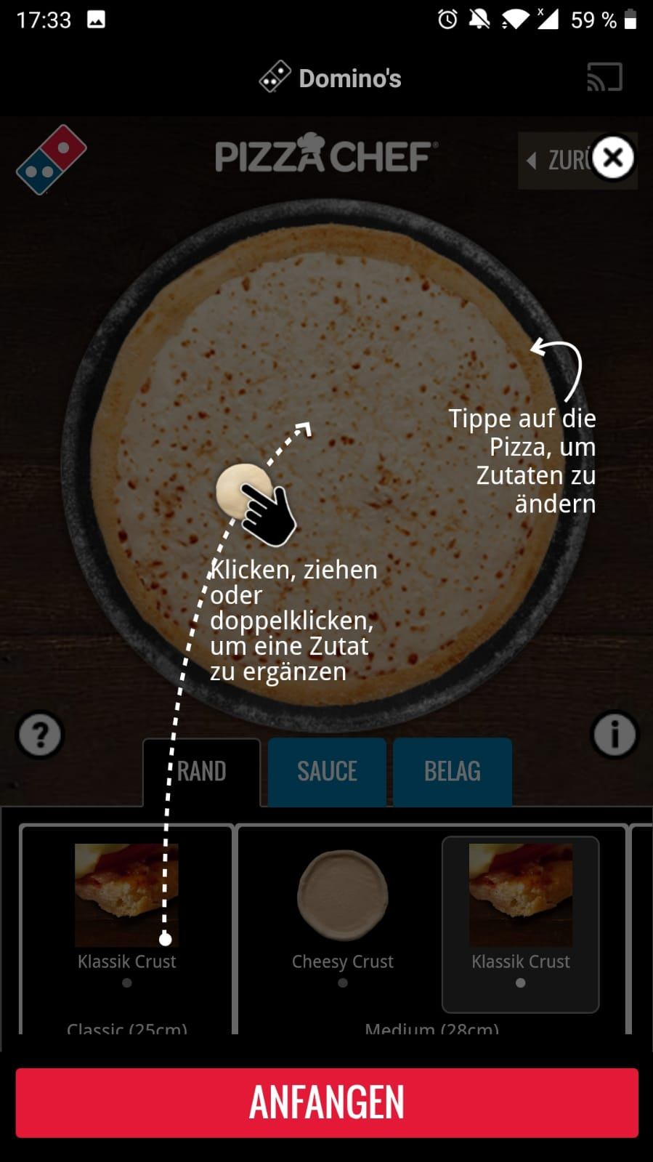

1. You can see what you choose everytime

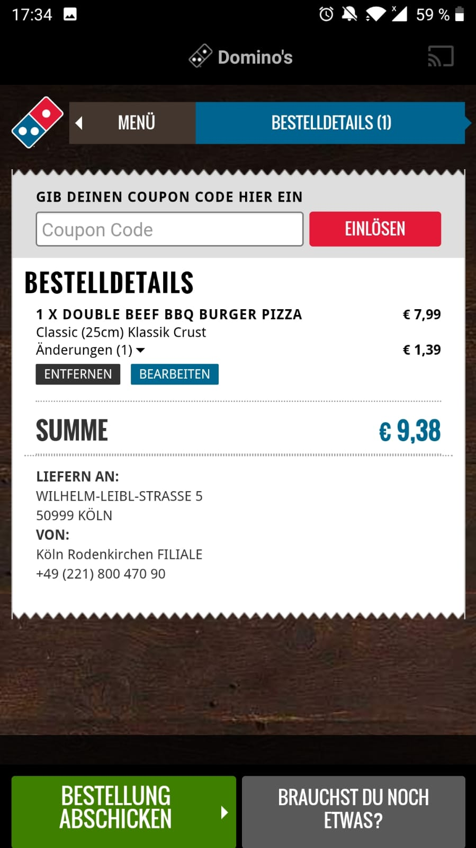

1. The price is automatically added, you can see the sum of the orders.

